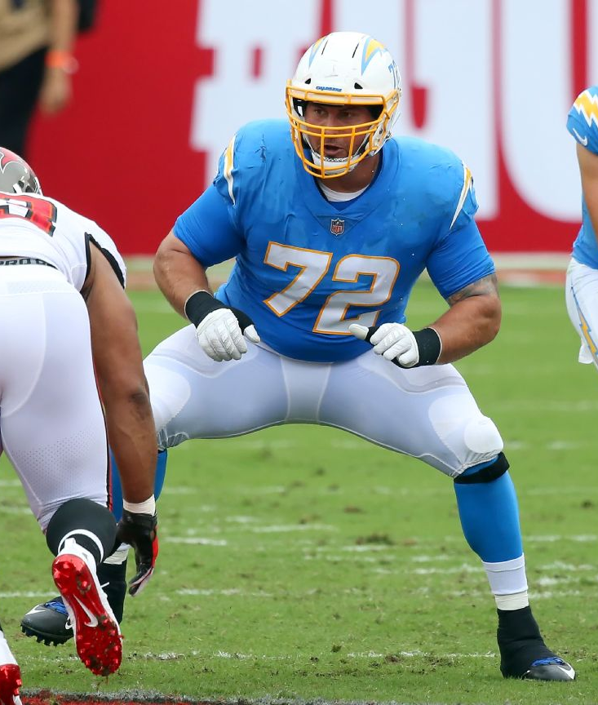
Ryan Groy Lineman Camp
“The Trenches … Where the Game is Won!”

Sponsored by the Middleton Gridiron Club

The most important positions in the game of football are the offensive and defensive line. The line is the point of attack; the line is the first step to a successful play on both sides of the ball.

WHAT WE HELP YOU ACCOMPLISH
- Improve your offensive and defensive line technique
- Improve your knowledge of offensive and defensive line play
- Create a fun environment to learn and push yourself to new ability levels

ABOUT US

It is the mission of the Ryan Groy Lineman Camp to improve or enhance the abilities of every participant at their position on either the offensive or the defensive line.

Extremely successful and proven individual techniques and skill execution along with the mental preparation for proper line play is emphasized.

The Ryan Groy Camp believes in a gradual progression to its teaching and instruction with an importance stressed on team concepts. The success is accomplished through organized, disciplined, and structured instruction from quality, experienced coaches. We combine this quality with a very low number of players per coach ratio.

*Besides OL and DL, we highly encourage FB, TE, and LBs to participate in the camp as we teach blocking and block defeat drills that will be extremely Beneficial to your season!

CAMP STAFF

Brad Rogeberg (Camp Co-Coordinator) Former Collegiate football player and coach. Coaching at Middleton High School for over 20 years.

Joe Poehls (Camp Co-Coordinator) Current Offensive Line coach for Middleton Cardinals. Coaching at Middleton for 10+ years.

Ryan Groy (Camp Technique Advisor) Former Middleton High School, Collegiate and Professional Lineman with the UW-Madison & Buffalo Bills & Los Angeles Chargers.

Derek Engler (Camp Technique Advisor) Former Collegiate and Professional Lineman with UW-Madison and New York Giants.

*Also helping are area Football Coaches & former players w/ many years of experience between them. Coaches from all schools in the area are welcome to come and be a camp staff member - we will teach you our techniques and pay you based on campers signed up to help instruct at our camp. If interested in coaching for us, please contact or email Brad Rogeberg or Joe Poehls (information listed below).

CAMP COST

$75 per camper for 3 day camp
$50 per camper for 2 day camp

*Financial Hardship is no reason not to attend - if you cannot afford the camp, please reach out to Brad Rogeberg or Joe Poehls at the email or number below and we will make it a possibility of you to still attend the camp

Equipment Campers Should Bring:

Helmet, Shoulder Pads, Cleats, Mouth Guard, Jersey (Your school needs to provide); HS only

CAMP TIME, DATE & LOCATION:

Grades 6-8: 5-6:30 pm June 28th & 29th

Grades 9-12: 7:00 - 9:00 pm June 28th/29th/30th Middleton High School Middleton, WI

Register at:

Form: Ryan Groy Camp Sign Up

PHONE: 608-829-9681; 608-829-9983
E-MAIL: brogeberg@mcpasd.k12.wi.us; jpoehls@mcpasd.k12.wi.us

